# Report for Jordan Cole-Hines (2024-10-01 to 2024-10-31)

Average Bat Speed: 54.00

Average Rotational Acceleration: 8.87

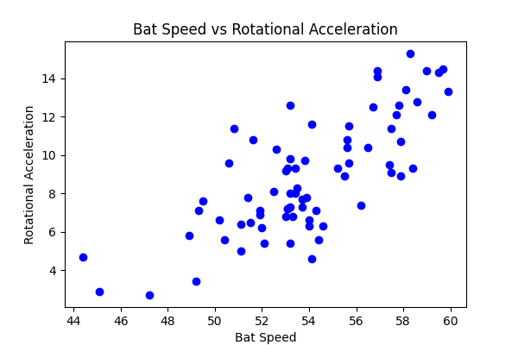

## Comments

Add comments here...